Lab 7.3.7 – View the Switch MAC Address Table

Topology
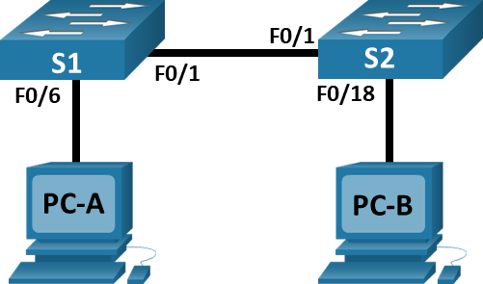

Addressing Table
Device | Interface | IP Address | Subnet Mask
S1 | VLAN 1 | 192.168.1.11 | 255.255.255.0
S2 | VLAN 1 | 192.168.1.12 | 255.255.255.0
PC-A | NIC | 192.168.1.1 | 255.255.255.0
PC-B | NIC | 192.168.1.2 | 255.255.255.0

Objectives
Part 1: Build and Configure the Network
Part 2: Examine the Switch MAC Address Table

Background / Scenario
The purpose of a Layer 2 LAN switch is to deliver Ethernet frames to host devices on the local network. The switch records host MAC addresses that are visible on the network, and maps those MAC addresses to its own Ethernet switch ports. This process is called building the MAC address table. When a switch receives a frame from a PC, it examines the frame’s source and destination MAC addresses. The source MAC address is recorded and mapped to the switch port from which it arrived. Then the destination MAC address is looked up in the MAC address table. If the destination MAC address is a known address, then the frame is forwarded out of the corresponding switch port associated with that MAC address. If the MAC address is unknown, then the frame is broadcasted out of all switch ports, except the one from which it came. It is important to observe and understand the function of a switch and how it delivers data on the network. The way a switch operates has implications for network administrators whose job it is to ensure secure and consistent network communication.
Switches are used to interconnect and deliver information to computers on local area networks. Switches deliver Ethernet frames to host devices identified by network interface card MAC addresses.
In Part 1, you will build a multi-switch topology with a trunk linking the two switches. In Part 2, you will ping various devices and observe how the two switches build their MAC address tables.

Required Resources
- 2 Switches (Cisco 2960 with Cisco IOS Release 15.2(2) lanbasek9 image or comparable)
- 2 PCs (Windows with terminal emulation program, such as Tera Term)
- Console cables to configure the Cisco IOS devices via the console ports
- Ethernet cables as shown in the topology
Note: The Fast Ethernet interfaces on Cisco 2960 switches are autosensing and an Ethernet straight-through cable may be used between switches S1 and S2. If using another model Cisco switch, it may be necessary to use an Ethernet crossover cable.

Instructions
- Enter your screenshots/answers below the items highlighted in blue and turn in the completed file without making any changes to the original content.
- Lab must be completed using actual equipment accessed remotely through NetLab or directly on campus. No credit will be awarded for labs submitted using Packet Tracer.
- Once the Lab is graded it cannot be resubmitted for a new grade.

Build and Configure the Network

Cable the network according to the topology. (Not required if using NetLab)

Configure PC hosts.

Initialize and reload switches as necessary. (Not required if using NetLab)

Configure basic settings for each switch.
      - Configure device name as shown in the topology.
      - Configure IP address as listed in Addressing Table.
      - Assign cisco as the console and vty passwords.
      - Assign class as the privileged EXEC password.
      - Assign IP addresses to interface VLAN1 on S1 and S2 according to the addressing table.

Examine the Switch MAC Address Table

A switch learns MAC addresses and builds the MAC address table, as network devices initiate communication on the network.

Record network device MAC addresses.
      - Provide screenshots of the output of ipconfig /all on PC-A and PC-B and highlight the physical or MAC address. (10 points)
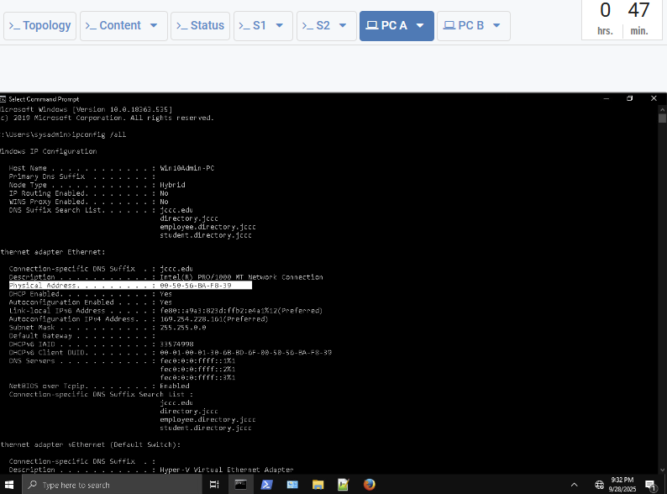
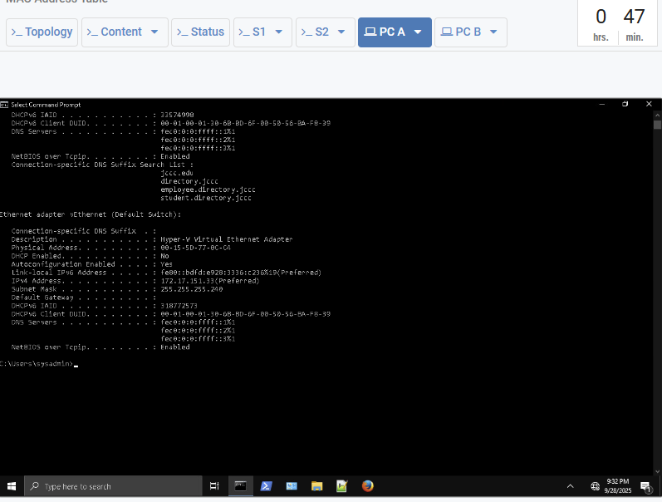
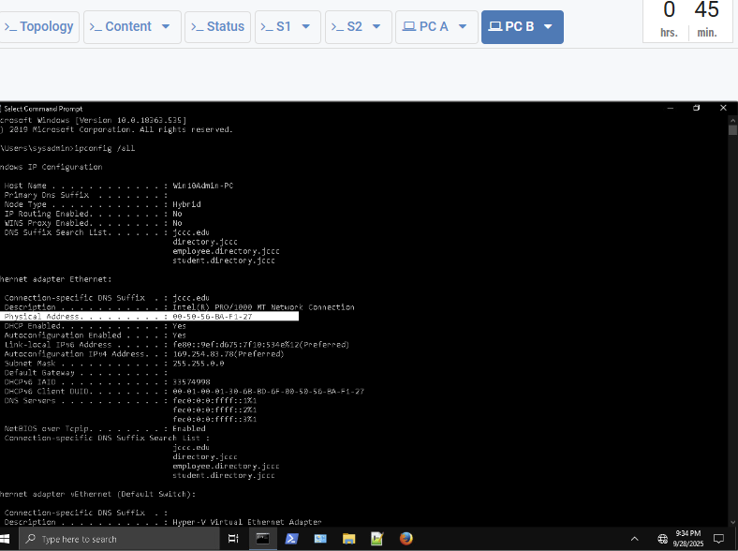
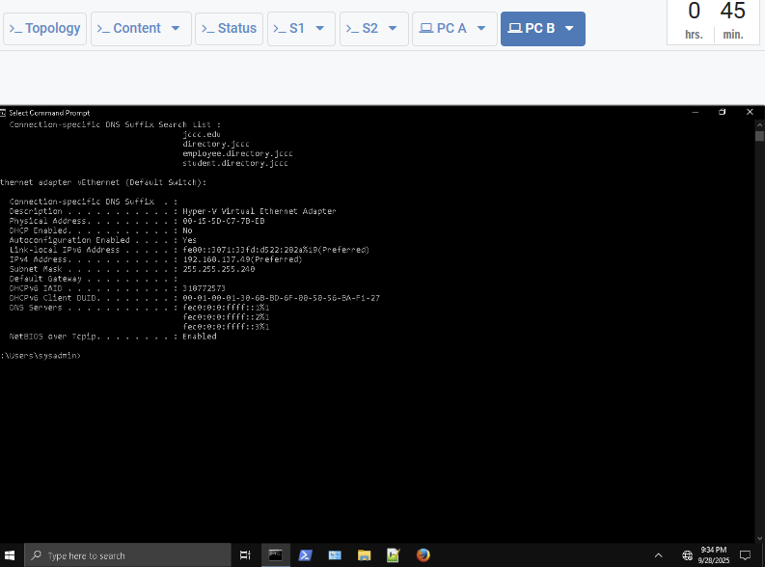

      - Console into switch S1 and S2, if using NetLab you can console to a device by clicking on it from the topology diagram or select its tab.

      - Provide screenshots of show interface VLAN1 on S1 and S2 and highlight the MAC or bia address. (10 points)

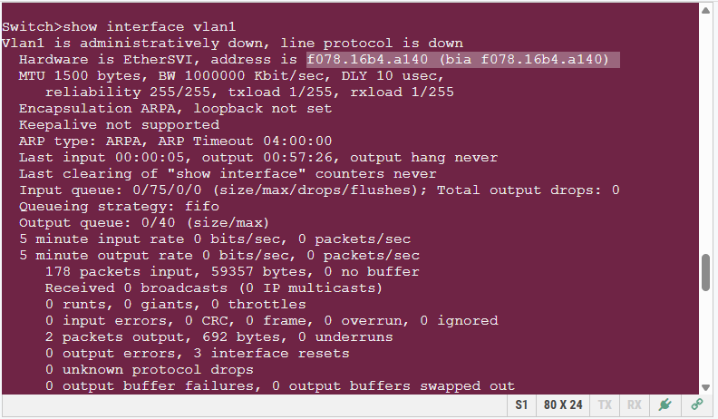
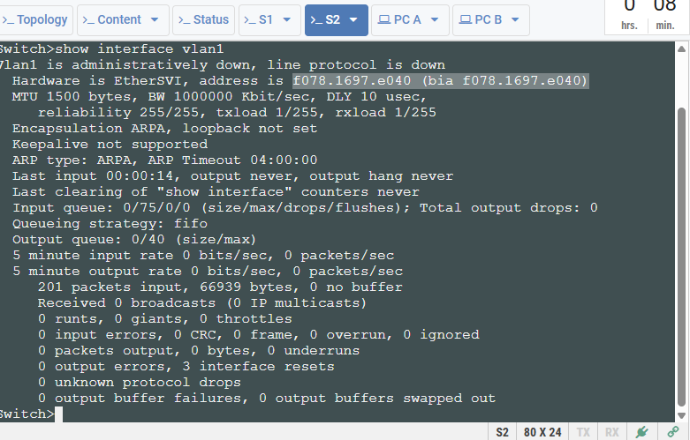

      - Provide screenshots of show interface F0/1 on S1 and S2 and highlight the MAC or bia address. (10 points)
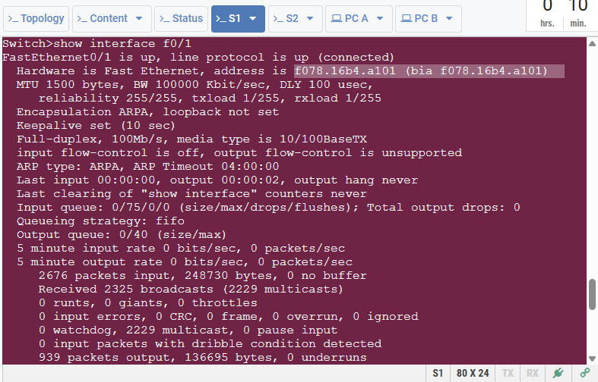
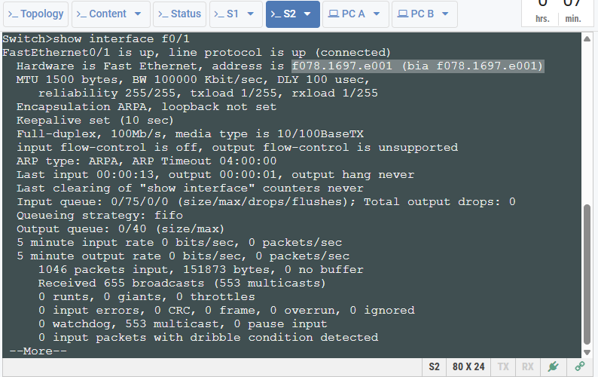

Display the switch MAC address table.

      - From S1 privileged EXEC mode, type the show mac address-table command and press Enter.

Provide a screenshot of the output of the command above. Make sure that the screenshot shows dynamically learned MAC addresses. (5 points)
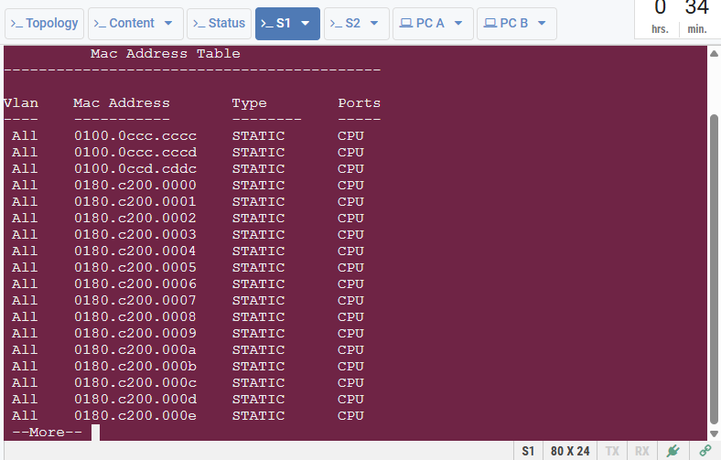
Even though there has been no network communication initiated across the network (i.e., no use of ping), it is possible that the switch has learned MAC addresses from its connection to the PC and the other switch.

What dynamic MAC addresses are recorded in the MAC address table of S1? To which switch ports are they mapped and to which devices do they belong? Ignore MAC addresses that are mapped to the CPU. (5 points)

If you had not previously recorded MAC addresses of network devices in Step 1, how could you tell which devices the MAC addresses belong to, using only the output from the show mac address-table command? Does it work in all scenarios? (5 points)

Clear the switch MAC address table and redisplay it again.
      - From the privileged EXEC mode of S1, type the clear mac address-table dynamic command and press Enter.
      - Quickly type the show mac address-table command again.
Does the MAC address table have any dynamic addresses? If yes, on which port it was learned and from which device. (3 points)
It has 23 dynamic addresses but it had 24 previously.

Wait 10 seconds, type the show mac address-table command, and press Enter. Are there new dynamic addresses in the MAC address table? (2 points)
No

Observe the PC ARP cache and the switch MAC address table.

      - From PC-A, open a command prompt and type arp -a to display the arp cache. Provide a screenshot of the output. (5 points)
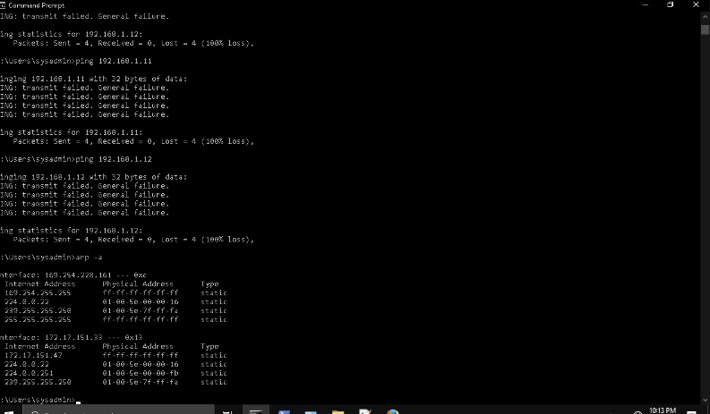

Not including multicast or broadcast addresses, how many devices IP-to-MAC address pairs have been learned by ARP? (5 points)
Note: Multicast addresses start with a number in the range of 224 to 239. Broadcast address would be 255.255.255.255.

      - Provide screenshots of pings from PC-A to S1, S2, and PC-B.

Ping from PC-A to S1. (10 points)

Ping from PC-A to S2. (10 points)

Ping from PC-A to PC-B. (10 points)

      - Provide a screenshot of the arp cache on PC-A. (5 points)

      - Display the MAC address table on S1.

Has the switch added additional dynamic MAC addresses to the MAC address table? If so, which addresses and devices? (5 points)

